**Quarterly Shifts & IPDA Data Ranges**

If the markets was truly random, how could anyone have an edge? Quarterly shifts apply to every market

It happens because the market needs to create new interest

Always look at price on a macro leve, monthly weekly and daily timeframe

Every 3/4 monhts theres a market shift, it may cause a consolidation or a retracement of whatever price swing had been evolving.

If the market is in a strong uptrend, you will likely not see a retracement but more a consolidation, theyll capitilize new longs that way and they might take a short term low on the daily to then go higher.

This month will be primarily about the daily chart. Buy programs can be on any timeframe

Underlying is what youre actually trading, benchmark is the underlying like dollar for USDJPY

And if the underlying makes a lower low and benchmark makes a lower high that could be GBPUSD and the dollar

This is all about the daily timeframe currently, nothing less

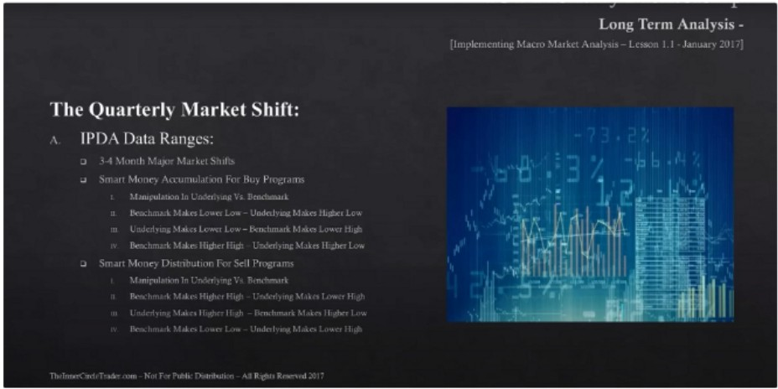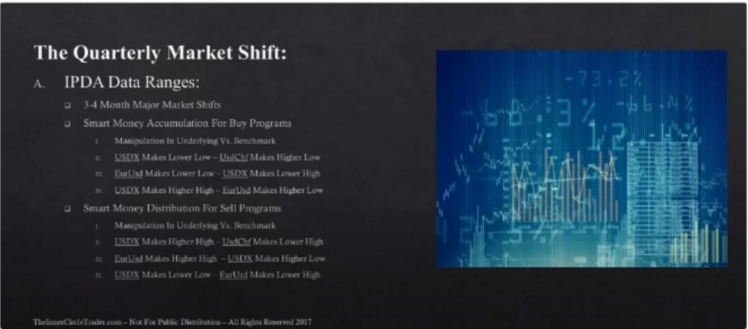

When things like this happen, you can anticipate it being a turtle soup on the daily.

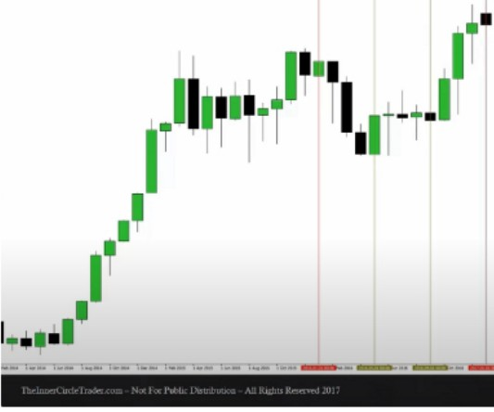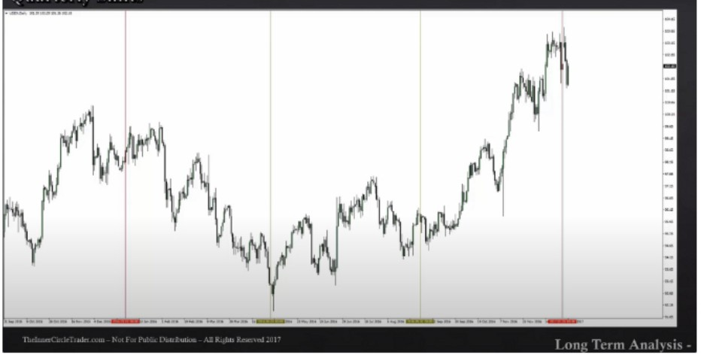

If the old low/high has a lot of long wicks then you'll be looking for a rejection block, instead of a sweep of the wicks it will be a sweep of the bodies

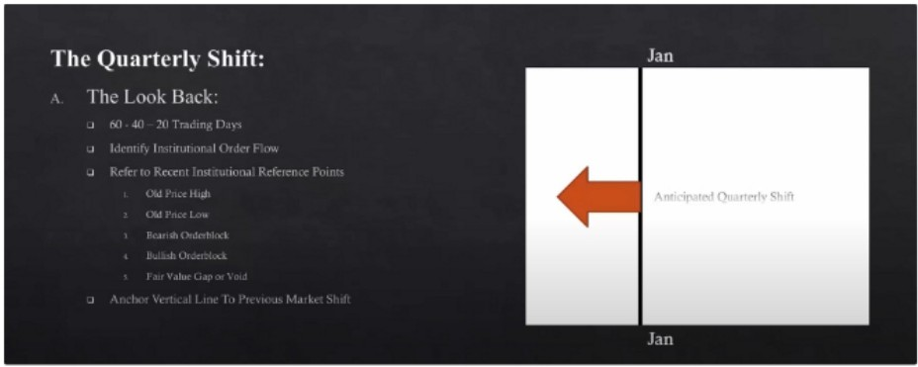 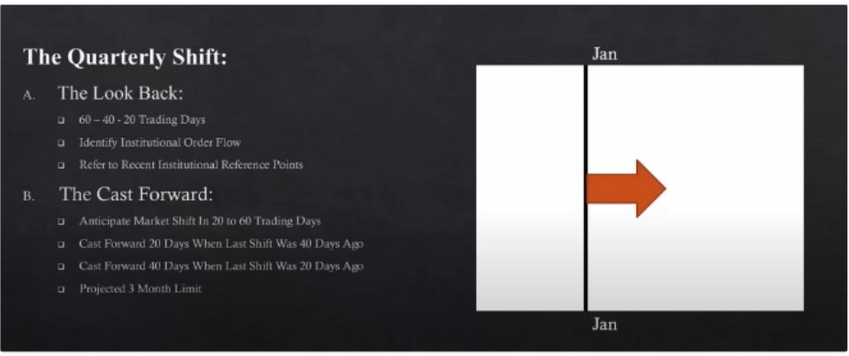



1:

The algo will do a shift between 60 and 20 days in the look forward phase

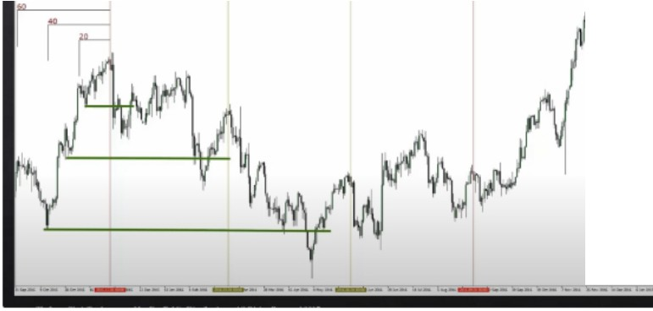

-

1-

I-

....

--

-

!:

,.-.

i:

·•

.-.

..

.

...

-

.-.

--

.-.

--

--

--

-

'

*I*

··--

---··

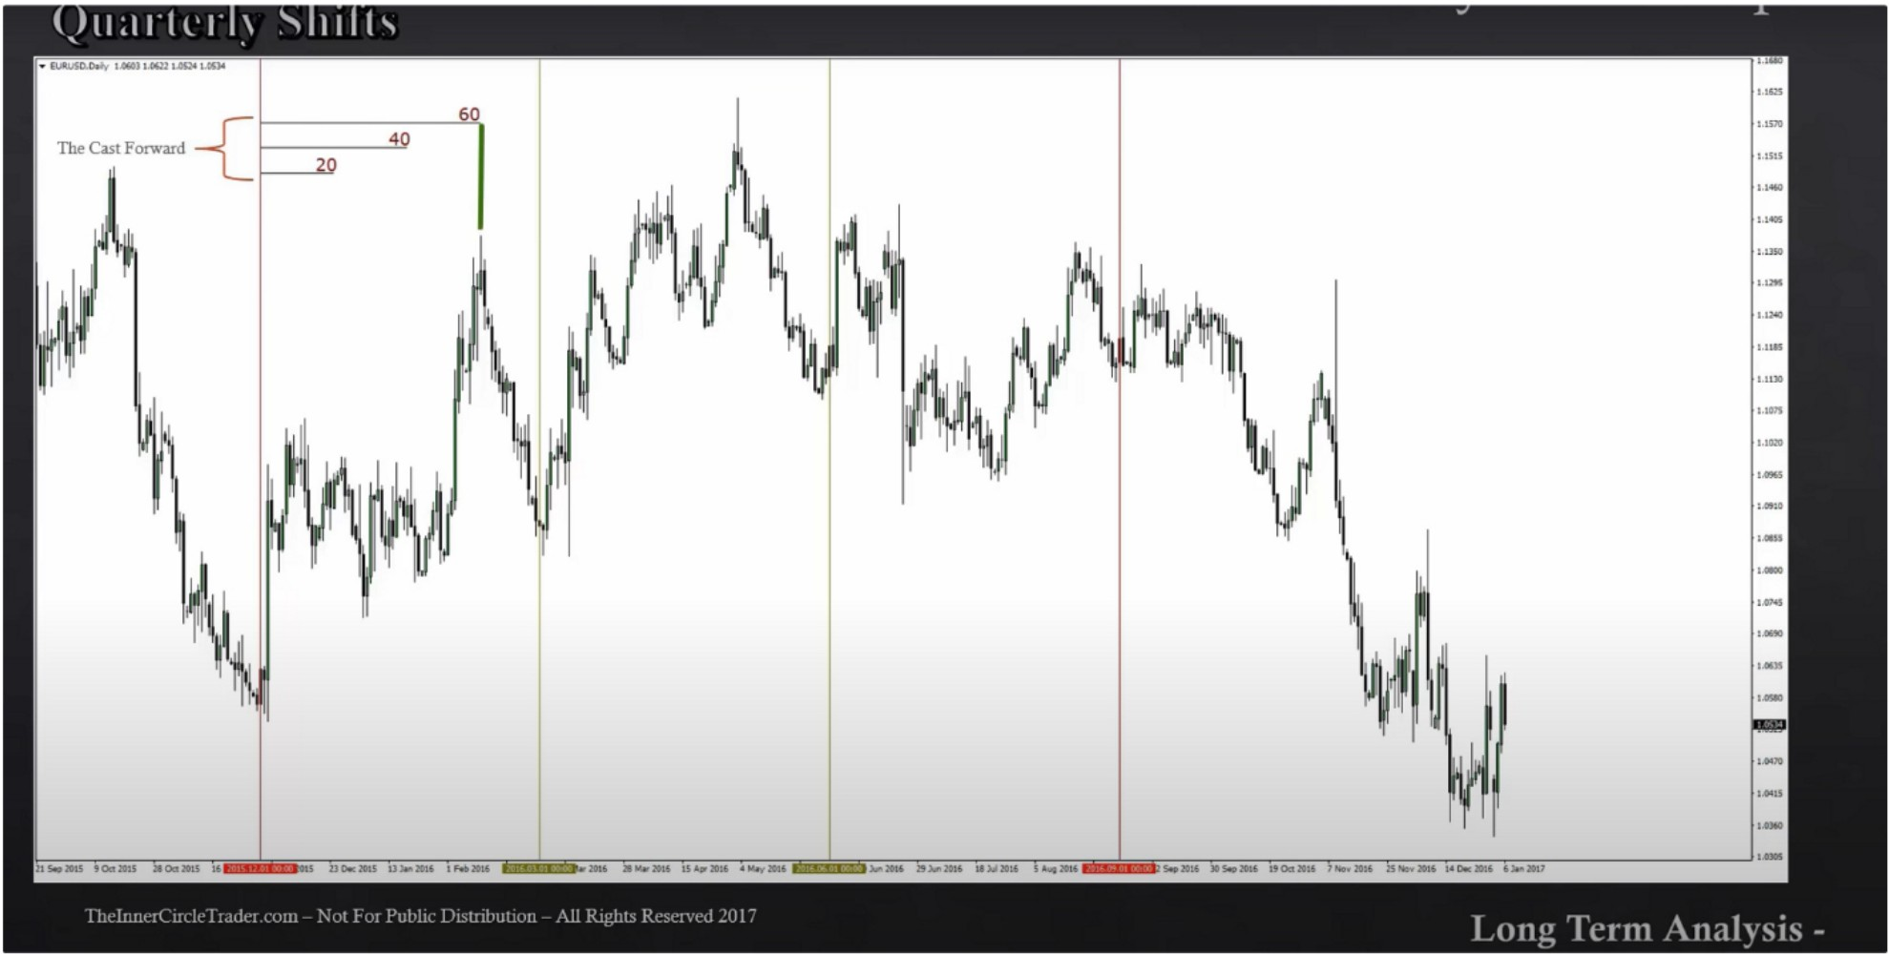We expect a setup in the next 60 trading days, you dont have to trade the daily if it doesnt suit you, this also helps with daily bias context

This will help map out WHEN the setups occur, time is very important

The algo will seek to do something in the first 20 days, 40 days, 60 days after the most recent market structure shift

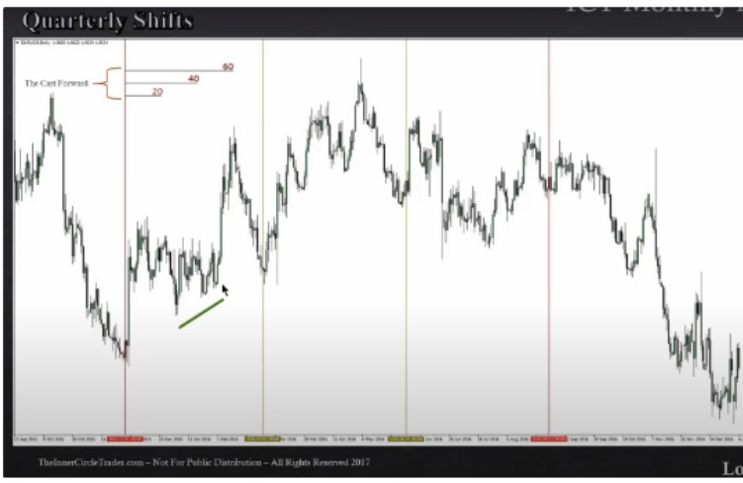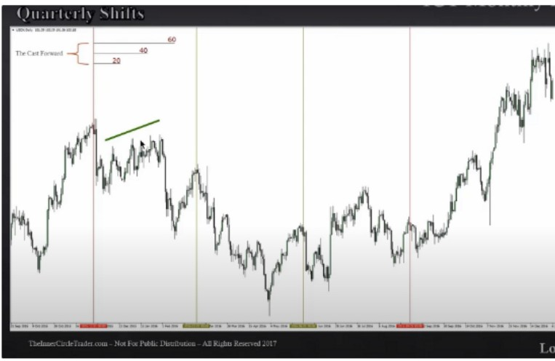

SMT between dollar and EU, the underlying is making higher lows and the benchmark is making higher highs. And its occuring within the 3/4 months and within the 60 days look forward phase

Theres a rhytm behind price

Every 3/4 months theres a sentiment shift to cause interest

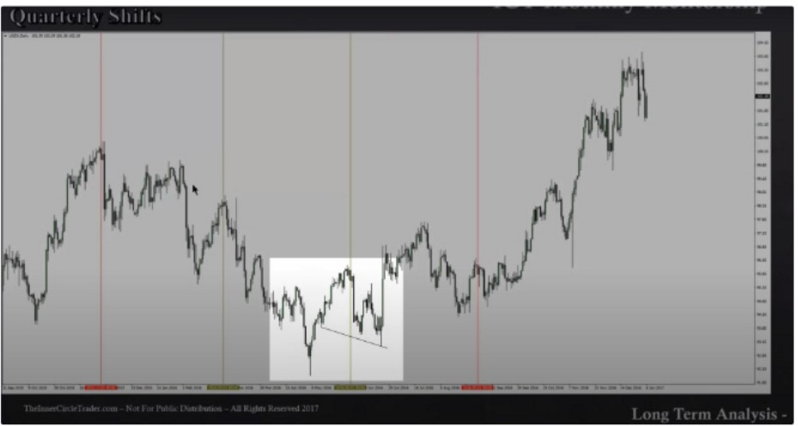

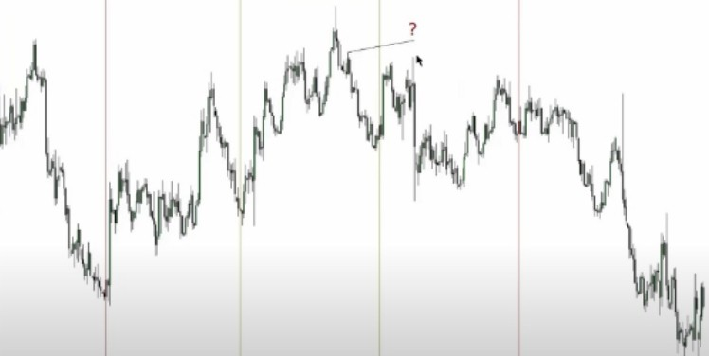

Market structure shift in may after 6 months of bearishness on the dollar. SMT with EU Suspect rally is SMT

You look back to where the liquidity is and look forward to where the next setup is and how long it might take

Go back to the previous closed month thats where you start the IPDA lines, when you see an obvious market structure shift

Arjo I Twitter, lnstagram I Linktree

Linktree. Make your link do more.

, https://t.co/HhmmTN1fUI

JavaScript is not available.

*"'!I* https://twitter.com/arjoio